The advancement in the technology has enable to rule out the probability of *“impossible tasks”.* We being the students of Computer Science, felt that we can address the issue of water we see around in the metropolitan cities. That is when the idea of this project was born.

The two main motivations to our project are:

1. **The increasing quantity of non-revenue water (unaccounted water)**
2. **Less revenue generated by the current billing system**
3. **The interstate dispute for water**

Image Source: <https://sensus.com/solutions/non-revenue-water-infographic/>

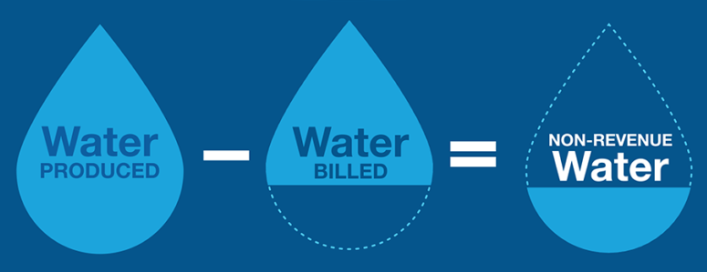 In this project we use the water sensors readily available to log water usage of a particular house, right from drinking purpose, bathing, gardening to *wasting*. This data is used for billing the house owner with different rates for different purposes where ***drinking purpose***being the lowest and ***miscellaneous*** being the highest charged. This increases the revenue generated without being a burden the house owner. Also we are going to integrate the payment with the bank database for ease.

Further, we plan to display real-time statistics to the house owner if required later on in the project.

The main customers for our product will be the government/ government bodies supplying water to public in our whole country like of Bengaluru, Chennai, Mumbai, Delhi, Kolkata etc. But at the beginning stage, we have restricted ourselves to design this product specifically for our beloved city Bengaluru. The BWSSB (Bengaluru Water Supply and Sewage Board) is the target customer at the current. If BWSSB is ready to accept our *smart billing system****,*** we would be very happy to set it up.